**STUDENT BLACKBOARD**

**-SHILPAN PATEL**

Student Dashboard is a project to provide students with tools that help them easily find the information they need under one roof rather than asking updates about assignments, books to other fellow students. Moreover, they can get information about their grades online. This system would benefit professor in terms of managing course contents and accessing information of any student within that portal.

The first screen that will appear will be the login page. In the login page the user needs to enter theie email address and password. The password and email will be provided by admin to all students and they can have access to their accounts.

If the user is new to the system they have the link to register as a new user but for that they will need admin’s help to provide them credentials.

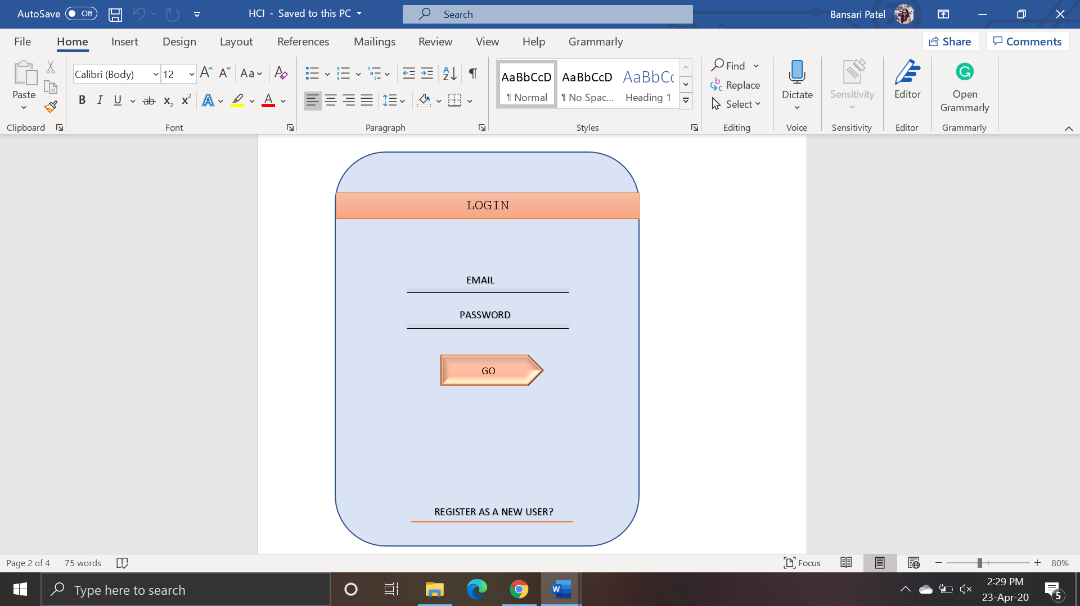

FIG 1. LOGIN PAGE

The next page after login will be the home page. Home page will have college calender as its display screen and it shows the events happening on the selected date.

Home page will also have tabs to redirect them to other page.

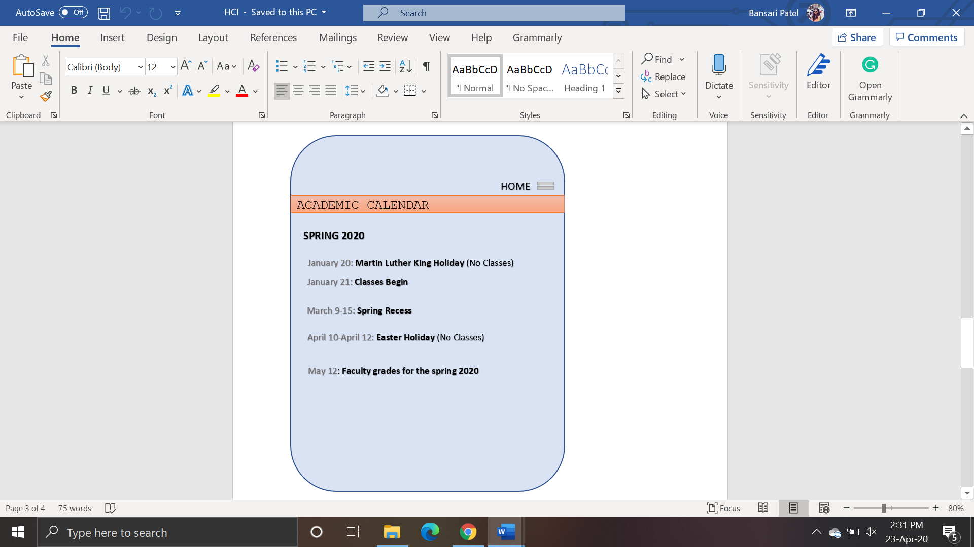

FIG 2. HOME PAGE

Below is the screenshot of Course creation module which will be done by the faculty. They can add the course number, title, credits and select the departmenr for that course. Once the faculty has created course it will show those subject to students for enrollment.

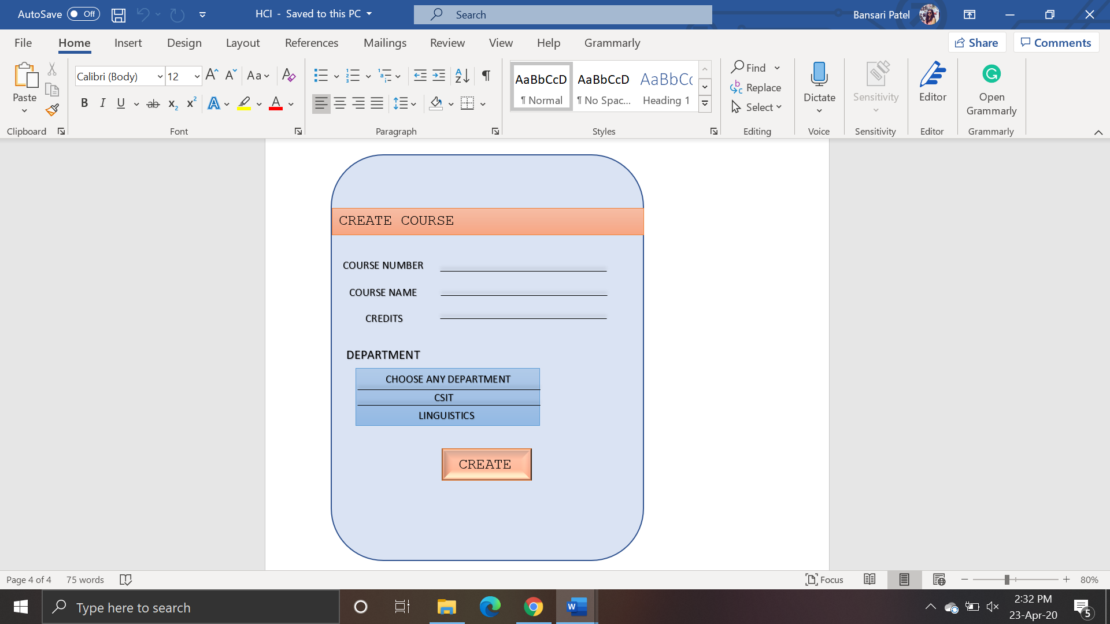

FIG 3. CREATE COURSE

Faculties can have access to view the list of students that are enrolled for their subjects. The following screenshot shows the list of students participated in some course.

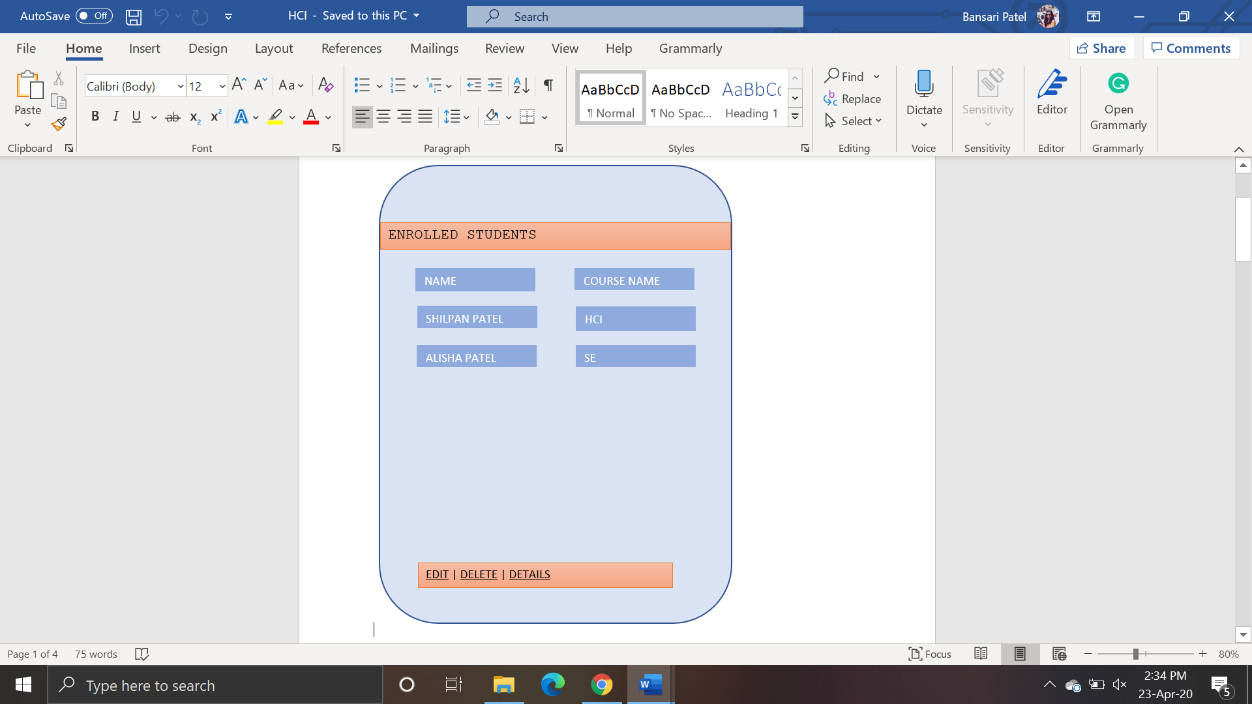

FIG 4. ENROLLED STUDENTS LIST

The following page is for students who wants to enroll in some course. They can view names first and select the elective courses available from the drop-down menu and after the selection is done, they can click on Enroll button to register themselves for that subject.

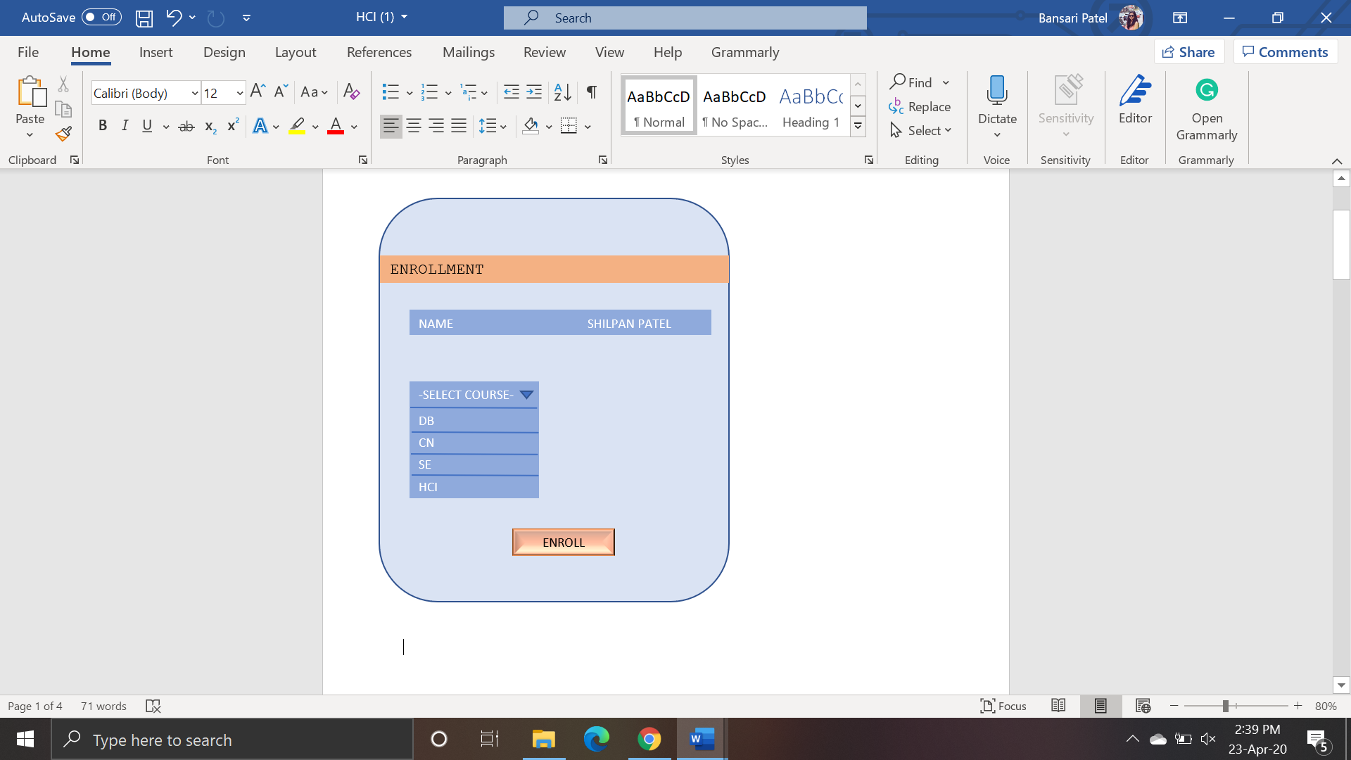

FIG 5. STUDENT ENROLLMENT

Assignment submission is the module in which the faculty will create the students will be able to see due dates along with the assignment file. The file can be an any word or pdf file, or it can be an image as well.

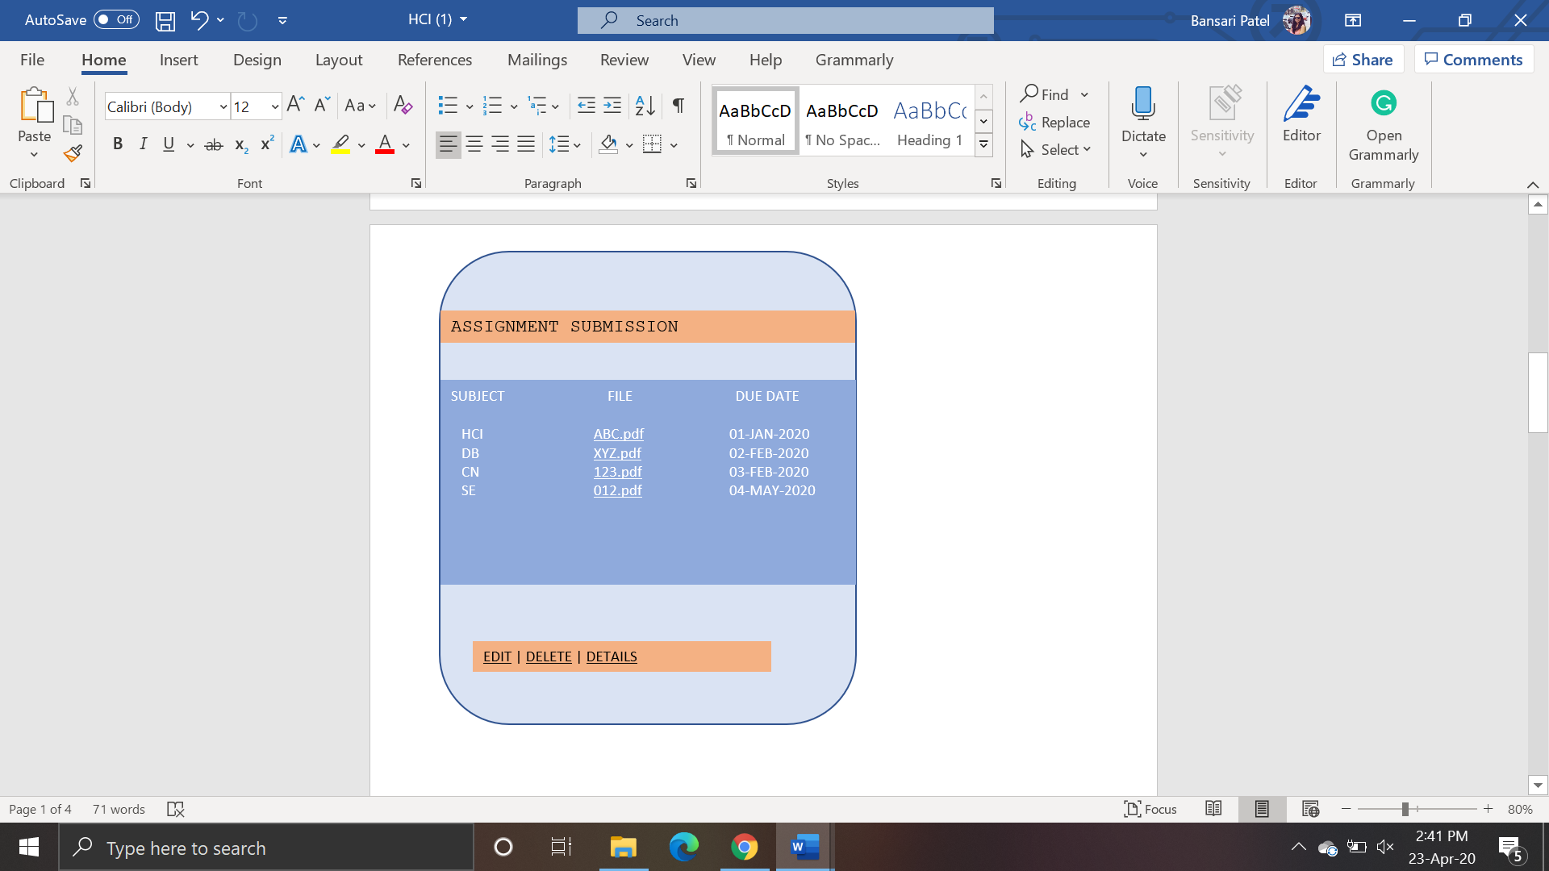

FIG 6. ASSIGNMENT

For the students, this page will allow them to submit the completed assignments. They just have to select the file and click on upload button to complete the task.

They will also be able to view the uploaded documents.



FIG 7. ASSIGNMENT SUBMISSION

The last page/module is book library in which the professor can upload documents or study materials and the students will be able to view or download it.

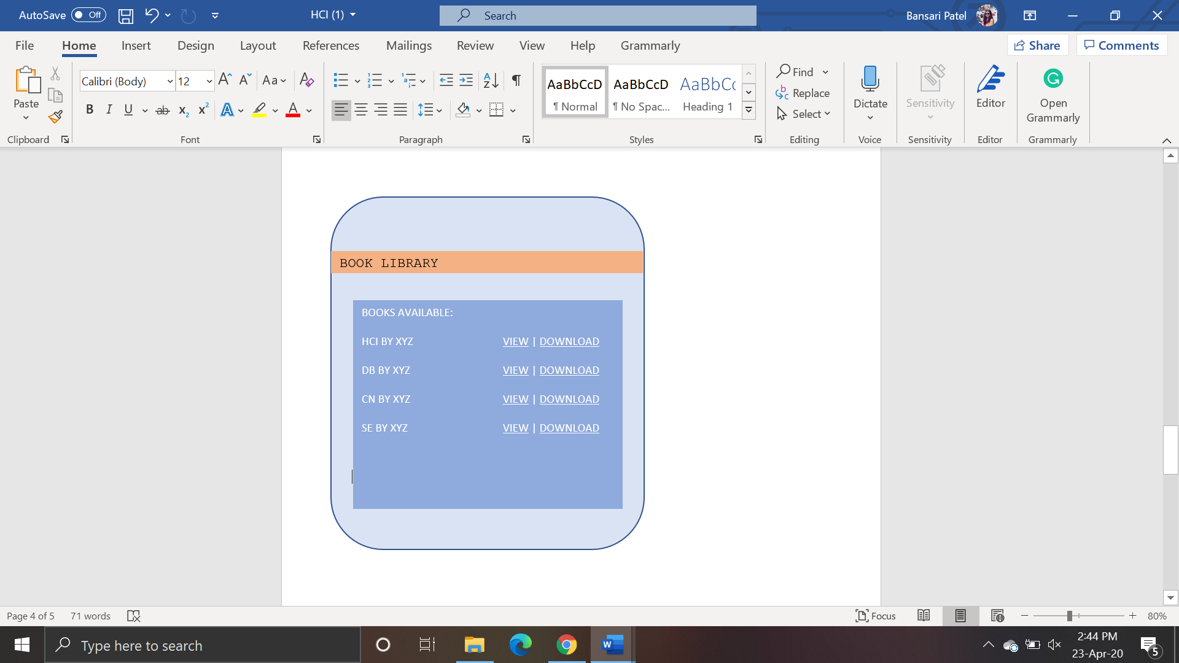

FIG 8. BOOK LIBRARY

For future development I will use the story-board prototype as it is easy to understand by any user as to how to do and what do to will be mentioned in the images. So, with the help of Storyboard prototyping, the user will get ideas for the input and what output they must get. The tasks that will be affected are view, download, and upload for different users. The prototype was modified in the way that it provides some basic guidelines for the users to interact with the system. The User base was the same for both the paper-type protocol and story-board prototyping. The only changes that are made in the interfaces are the authorities that will be given to the user on the basis of their login credentials.